Technical Writing Sample

**You can find my samples on GitHub!** <https://github.com/taiylarball/TaiylarBall>

**Here is an example of one you can find:**

* Go to <https://www.paypal.com/disputes/> and login with their paypal login
* Once logged in they will see two tabs: *Open Cases* and *Closed Cases 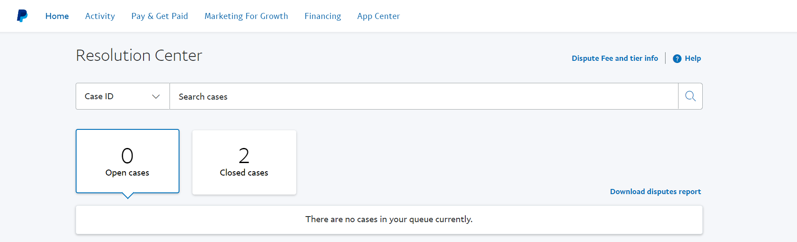*
* They can either click *Download dispute report* or by clicking on either tab that has a case they will see a list of their chargebacks with the reason clearly stated. They can also hit *view* for even more information:

